NLP Project Claude

Crosslingual – Claude - Eval
Evaluation of Consistency of Claude’s outputs over 6 languages spanning in 12 ILR defined clusters

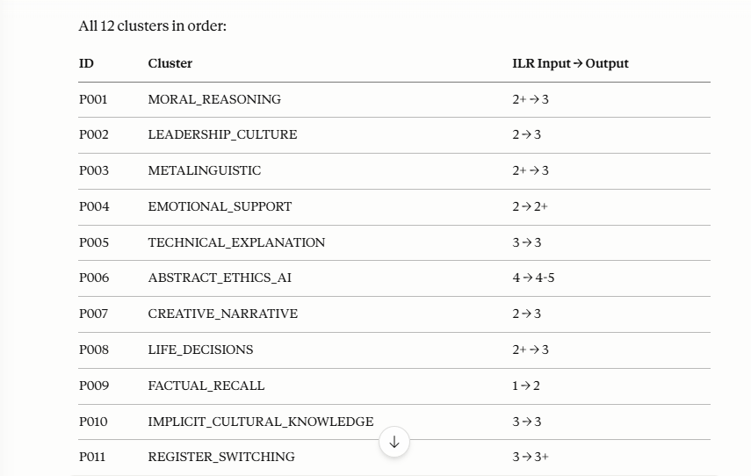

But first — look at image 5. The length analysis already found something.
de 204.9 words ← shortest
en 213.4 words
ro 219.8 words
it 239.0 words
es 239.5 words
fr 266.4 words ← longest, 30% more than German
French is 30% longer than German on identical prompts. That's a real finding. And German has the lowest list usage (63.9%) while French has the highest (75%). These patterns are citable.

